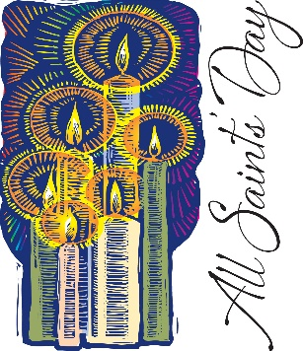

All Saints Sunday
Grace Evangelical Lutheran Church
November 6, 2022

We Remember with Thanksgiving
those who died
November 2021 - October 2022

Members

Nancy Fitzgerald March 9, 2022
Bobby Hull November 28, 2021
Mike Jones September 23, 2022
Joe Moyer January 6, 2022
Pete Rufe July 5, 2022
David Shields November 12, 2021
Barb Susen June 13, 2022
Dick Tomey March 9, 2022

Family and Friends

Dennis Casey July 20, 2022
Lisa Fridley Dofflemyer February 20, 2021
Jude Farrey May 5, 2022
Michelle Matthews May 21, 2022
George Toop May 21, 2022

Given in Memory of:

Ty Elliott Nancy Fitzgerald
Richard "Rick" Glidden Bobby Hull
Geraldine and Gary Mitchell Joe Moyer
Fielder Pitzer Pete Rufe
David Shields Barb Susen
Richard Tomey

Given in Honor of:

Jean & Tripp Franklin Jerry & Gwen Kite
Yochanan (John) S. Proctor

The Memorial Gifts Were Given by:

Anonymous, Berenice Archambeault, Augusta Fire and Rescue, Jeff & Deborah Avery, Dennis & Anne Barnes, Price & Emily Boxley, Brandon Circle Homeowners Association, Jean Brydge, Marg Cloutier, Ed & Judy Croft, Leslie & Robert DeFord III, Nancy Dowdy, Bradley S. Elliott, Chuck & Judi Goodrich, Donna Gum, Hand Bell Choir, Douglas & Jeanne Hawpe, Carolyn & Bobby Hite, Joseph Julian, Wilda & Brad & Owen Keefer, Jerry & Gwen Kite, Ron & Sandra Knicely, Arthur "Art" Lively, Bill Lucas, Sharon Machen (Thomas Cousins), Donna & Richard Marshall, Gene & Jan McCombs, Dawn McCray, Linda Meyer, Jean Morgan, Robert Moyer, Newcomers Club, Steve Painter, Doris Pitman (J.R. & D.D.), Betty Jane Pitzer, Lewis & Dottie Price, David & Vivian Proctor, Robert & Deborah Russell, James & Dorothy Sayre, Everett Stratton, Deloris Wertman & Wertman Family, Carol Wolf.

Memorial Gifts Given for the Following:

Grace Building Fund, Grace Choir Fund, Grace Property, Grace Thanksgiving & Memorial Fund

